CLASSIFICATION DEBT


Guy Desharnais
Vice President, Project Evaluation at OR Royalties Ltd
June 16, 2026
Why do operating mines typically have more than twice as many drill holes as development projects within the same resource classification?
Confidence in the mining industry continues to be hit by repeated downward revisions to the mineral resource estimations; I argue here that a major contributor to this trend is a lack of drilling in development projects (Classification Debt). The majority of failures affect precious metal development projects, and most of the resource estimation revisions are revealed after entering production and tonnage and grade reconciliations fall well short of the anticipated results. The most prominent example is Rubicon’s Phoenix Project near Red Lake which had ~90% of the gold mineral inventory erased following an attempt at production. A compilation of the 43 gold and silver mining projects built in Canada since the Phoenix failure in 2015 showed that 18 of these (42%) underperformed significantly in head grade; 7 of these (16%) were shuttered within 3 years after construction (1, 2, 3, 4a, 4b, 5a, 5b, 6a, 6b, 7a, 7b, 8, 9a, 9b, 10a, 10b, 11a, 11b, 12a, 12b, 13a, 13b, 14a, 14b, 15a, 15b, 16a, 16b, 17a, 17b, 18a, 18b). These shortfalls were variably ascribed to “unexpected grade uncertainty” or “unplanned dilution”. Little or no disclosure is provided regarding factors of over-estimation that led to the underperformance; this is not a requirement of NI 43-101. Understanding the root causes of these failures is further masked by new drill results between estimations thus expanding mineralized footprints, as well as rising gold prices and changes in assumptions used in the updated studies (cut-off grade, pit optimization etc). One common thread in all these cases, is a commitment to increased drilling to better understand the geometry and grade distribution of mineralized zones.
Mineralized bodies appear to have simple geometries when sparsely drilled; the actual complexity of these systems can only be recognized with sufficient sample resolution. To illustrate this, consider that any three mineralized drill intervals necessarily resolve geometrically as a perfect plane; the actual geometry may comprise 2 or 3 separate veins or a highly folded deposit. The geometric problem is further complicated by the requirement to define the shape and edges of the economic portions of the mineral inventory (domains above cut-off grade), which will often require additional datapoints to resolve. Tighter drill spacing for the projects referenced previously would have resulted in better understanding of grade and geometric continuity and a classification that would necessarily be more aligned with actual risk adjusted ore tonnage and grade. Therefore, although many factors contributed for each of the failures referenced, they all had a failure of classification: the risk was underestimated. Essentially, these projects were carrying what I term Classification Debt: a deficit in data points (primarily drilling) for the currently reported resource classification.
In an attempt to quantify the level of Classification Debt affecting the mining industry I compiled publicly available drill spacing data for operating mines and development projects. The core assumption is that operating mines have adjusted their drill spacing to achieve a risk level that is appropriate for each level of classification and deliver on their production commitments; in contrast development projects have not yet had the benefit of mine reconciliation to calibrate the risk to the estimates. The compilation was accomplished by reviewing more than 200 NI 43-101 technical reports between 2022 and 2024, and by extracting the classification methodology including the approximate maximum allowed drill spacing for Indicated Resources. The analysis was limited to Indicated Resources because these are generally the core component of economic studies (Measured and Inferred Resources classification schemes are often multiples of the Indicated classification). Critics of the link between classification and drill spacing may contend that drill spacing is not the primary driver of some classification schemes; my counter to this argument is that any measure of risk, geostatistical (e.g. kriging efficiency, conditional simulations) or otherwise, is necessarily related to proximity to samples. Furthermore, subsequent drilling campaigns inevitably have a prescribed drill spacing to achieve a targeted level of classification. I also created 2 broad categories of deposit continuities in an effort to compare like-for-like projects (Figure 1):
Lower Continuity Deposits: primarily comprising vein hosted orogenic or epithermal deposits and base metal deposits that have limited thickness and geometric extension such as smaller VMS deposits.
Higher Continuity Deposits: primarily comprising thicker disseminated deposits of any origin including some orogenic gold deposits and porphyry deposits. Coal, potash, iron and other laterally extensive and geometrically simple deposit types were specifically excluded from the compilation.
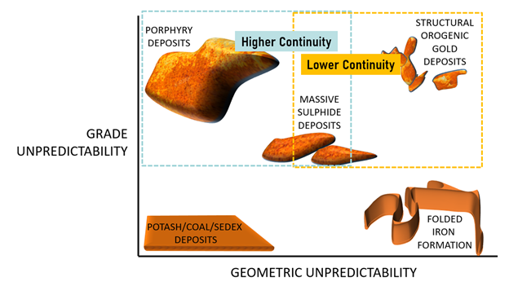
Figure 1. Graphical representation of the two categories of continuity upon which deposits were assigned.
Data Analysis
Thirty examples within each category were collected to achieve a sample set that has some statistical reliability. This exercise was imperfect for reasons that are summarized in the Compilation Reliability Discussion section at the end of this paper.
Figure 2 shows the extracted approximate maximum drill spacing for Indicated Resources in Lower Continuity category for operating mines in red and development projects in blue. Note that development projects here are limited to those projects that are not within companies that have operating mines (more on this later). The term maximum is used because it is possible that the actual typical drill spacing is tighter than the interpreted upper limit prescription. We observe a similar range of results from approximately 20m to more than 140m between populations. Given the distribution does not follow a normal distribution, the median is more appropriate measure for the typical values which is 35m for operating mines and 67m for the development projects. This translates to 3.6 times more drilling for a given surface area for operating mines than for their analogous development projects. The additional drilling might seem curiously high, until you consider that narrowing the prescribed drill spacing by half requires four times more drill holes.
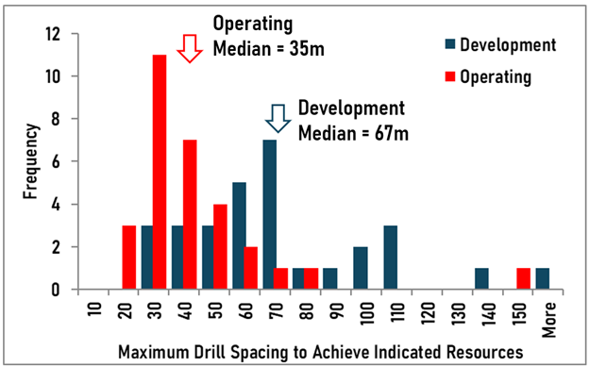
Figure 2. Histogram of approximate maximum drill spacing required to be assigned Indicated Resource classification for deposits categorized as Lower Continuity. Red bars are from resources from operating mines, blue bars are from development projects
Figure 3 shows the extracted approximate maximum drill spacing for Indicated Resources in the Higher Continuity category for operating mines in orange and development projects in blue. Note that development projects here are limited to those projects not within companies that have operating mines. We observe a similar range of results from approximately 30m to more than 140m between populations. The maximum drill spacing median is 48m for operating mines and 80m for the development projects. This translates to 2.8 times more drilling for operating mines than for development projects.
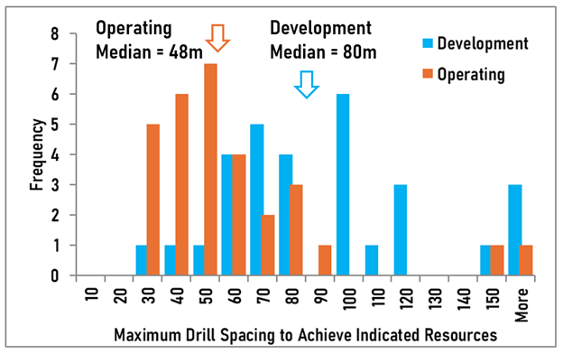
Figure 3. Histogram of approximate maximum drill spacing required to be assigned Indicated Resource classification for deposits categorized as Higher Continuity. Orange bars are from resources from operating mines, blue bars are from development proj
The histogram of Figure 4 explores whether development projects within mining companies have drill spacing consistent with their operating mines from the same category of Higher Continuity. We observe that these development projects have similar drill spacing regardless of whether they are managed by mining companies or development companies (green and blue bars respectively).
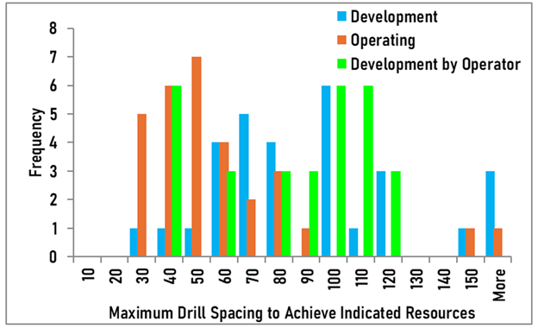
Figure 4. Histogram of maximum drill spacing required to be assigned Indicated Resource classification for deposits categorized as Higher Continuity. Orange bars are from resources from operating mines, blue bars are from development projects and the
Conclusions
Despite the difficulty involved with the collection and compilation of data from technical reports (see Compilation Reliability Discussion at the end of this paper) important conclusions can be made. Firstly, operating mines have median maximum drill spacing of 35m for Indicated resources for deposits of lower continuity and 48m for those of higher continuity. This is in contrast to 67m and 80m for development projects respectively, which required 3.6 and 2.8 times more drilling to achieve the same drill spacing on a surface area basis. The drill spacing for operating mines is in line with the author’s expectation having worked at or evaluated mineral resources at dozens of mines internationally.
Indicated Resources or Probable Reserves are used to make capital decisions. For underground mines this implies sufficient drilling has been completed to dedicate capital to design and excavate drifts towards a mineralized shape that allow access for further delineation or mining. If the zone is in the wrong location, orientation or does not contain the expected grade, it follows that significant capital is wasted and could put the operation at risk. The classification risk is imminent at operating mines and the impact will be felt in a relatively short time span. Qualified Persons classifying resources at operating mines typically have previously worked at similar mining operations or have felt the pain of designing capital projects that have underperformed because of insufficient information. Reconciliation exercises at mines calibrate the required level of information to reduce the risk to a sustainable level balanced with the constant pressure to reduce cost by not over-drilling. These are invaluable benchmarks that should be available for all Qualified Persons.
Interestingly, mining companies appear to allow wider drill spacing for development projects within their own portfolios. It is likely that these projects suffer from the same issues described below, and in many cases they were acquired from development companies, with inherited Classification Debt.
The critical question is: why do operating mines have more than twice the drilling than for an equivalent classification of development projects? Each case is different, and there is a complete overlap between the data, so the generalizations made herein can be understood to be limited to projects that are outside the range of reasonable drill spacing. I propose here that some Qualified Persons for development projects are biased to allowing wider drill spacing for many reasons, all of these are linked with cognitive biases. Cognitive biases are systematic, unconscious errors in thinking that deviate from rationality or norm, distorting how people interpret information and make decisions. These mental shortcuts, or heuristics, often lead to poor judgments. The author is not excluding himself from these cognitive factors:
1. Some Qualified Persons may have inherited a project that has an existing Classification Debt. There is enormous pressure to increase resources between subsequent estimation exercises.
a. Anchoring Effect: a cognitive bias where individuals rely too heavily on the first piece of information offered (the anchor) when making decisions. Assumptions in the estimation and classification are too often retained from previous estimation exercises to achieve a result that is similar or better than the previous estimate. Here we introduce the term “Inherited Classification Debt”.
2. Some Qualified Persons are influenced by the power balance with their supervisors or clients and the nature of the consulting agreements:
a. Authority Bias: a cognitive tendency to overvalue the opinions, instructions, or expertise of authority figures (leaders, experts, or those in uniform), often leading people to accept information without critical evaluation. The supervisor or client will apply pressure (often not very subtly) to achieve a result that is desired, and our human nature is to comply to avoid conflict, stress or embarrassment.
b. Commitment Bias: the tendency to persist with past behaviors, or commitments, even when they are irrational or harmful due to a psychological desire for consistency, to maintain self-image, or to avoid appearing inconsistent to others. This speaks primarily to the power balance between a client and consultant, the consultant is committed to provide a result that satisfies the client. A contract is entered into before the Qualified Person has had a chance to ascertain whether there is an issue with Inherited Classification Debt, and they will generally strive to achieve a result that will appease the client to ensure satisfaction and future contracts.
3. There is no consensus of the toolset that should be applied to assess risk to mineral resource estimates. The methodology of classification is often described as qualitative in nature, which is an objectionable rationalization.
a. Benchmarks are Not Available: This study has demonstrated that it is not possible to reliably extract the actual drill spacing from operating mines because the current NI 43-101 code does not require its disclosure. Operating mines have the benefit of reconciliations and, although difficult to find perfect analogues, should be considered when applying and validating classification schemes to similar development projects.
b. Use of the Variogram Range: The most commonly used metric used in classification is from interpretation of the variogram range (56% for development projects and 38% for operating mines in this compilation), which has been discredited as a useful tool (Deutch 2025). The continued use of the variogram is in part due to a cognitive bias of my own creation: Quantifiability Bias: The tendency to rely on a metric or assumption because it produces a specific number, regardless of whether the result is related to what is being estimated. This will be expanded on in a separate paper, but some Qualified Persons find comfort in using this metric because the variogram range “feels” like a quantifiable measure that can be defended, and it is out of reach for non-technical supervisors or clients.
c. No Attempt at Quantification of Risk: Only 3% of all the reviewed technical reports used conditional simulations to quantify the risk on grade estimates. Not a single technical report attempted to quantify the risk on the geometry of the mineralized body. Precious metal deposits have an additional pernicious feature that is generally disregarded in the industry: the geometric risk of “domains above cut-off grade”. The application of a cut-off grade creates a secondary set of geometric risks that is misunderstood; this risk increases dramatically as the proportion of blocks above the cut-off grade decreases.
Broadly speaking, operating mines have more than twice the drill holes than their equivalent development projects. The stated mineral inventory in many of these projects has not yet been earned with sufficient drilling and results in a Classification Debt, which must be paid. There is extreme reticence to pay down Classification Debt because it involves investing several multiples of past drill campaign to earn what the stakeholders already consider to be the current state (resulting in metal losses for many projects). In many cases the Classification Debt was inherited from a project that was purchased, and the new owners are very reluctant to admit they did not properly assess the risks prior to the investment. Unfortunately, incentives of the current system, most importantly a company’s share price, will inhibit management teams from taking the hit, and paying down the Classification Debt prior to making further investment decisions. We can expect the mining industry and investors to continue suffering major downward revisions to mineral inventories until we see a reversal in the approach to classification.
Compilation Reliability Discussion
The extraction of drill spacing from technical reports was imperfect in many ways, however, the number of examples and the conscious efforts at an unbiassed approach supports the general conclusions of this exercise. The following are the limitations of this study:
1. The actual drill spacing for Indicated Resources is rarely stated explicitly in the NI 43-101 technical reports. Reliance on general descriptions, and some interpretations of the result from classification schemes was necessary in most cases.
2. The maximum limit of classified drill spacing may not represent the typical distribution of drilling. For example, in many cases a description is as follows “blocks that have an average distance of less than 40m from the 3 nearest drill holes were classified as Indicated Resources”. This description translates to a maximum drill spacing of approximately 56m, however the actual drill spacing over the majority of the deposit might actually be on robust 40m drill grid.
3. Even when the prescription of drill spacing is stated or extractable from the description, many qualified persons describe a subsequent step of manual or algorithmic step to manage the spotted dog effect. This step creates additional uncertainty on the actual drill spacing.
4. The categorization of deposits into either “lower continuity” and “higher continuity” is an oversimplification, and requires broad generalizations based on limited knowledge of the deposits in question.
5. In some rare cases it was impossible to estimate the drill spacing; those examples were excluded from the dataset.
6. I am a human, and thus susceptible to cognitive biases (e.g. Confirmation Bias and Motivated Reasoning) to achieve conclusions that I expect. This is particularly risky given the commonly vague descriptions that require an interpretation to a single value. I made conscious efforts to be measured while compiling data.

